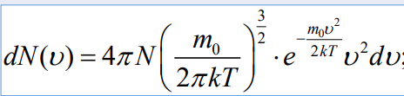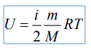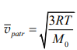

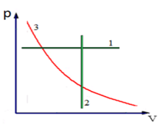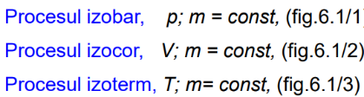

Distribuția Maxwell

Energia internă a gazului ideal

Viteza medie pătratică





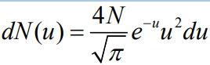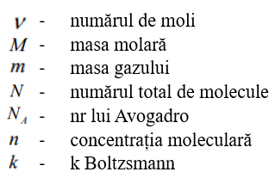

Distribuția Maxwell după viteza relativă

Procesul izocor Procesul izobar Procesul izoterm Procesul adiabatic

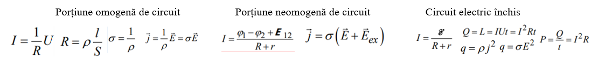

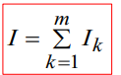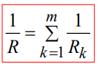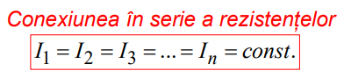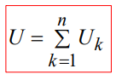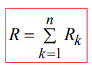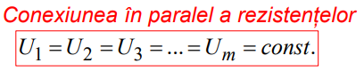

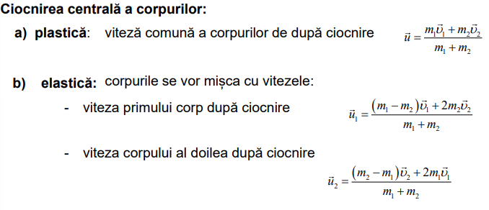c

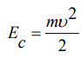

**

**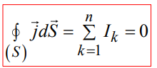

**

Legea conservării sarcinii

Viteza medie Viteza instantanee Accelerația Mișcarea curbilinie tangențială și normală Distanța parcursă

Forța care acționează asupra unui punct material la mișcarea curbilinie

Legea fundamentală a dinamicii

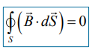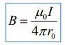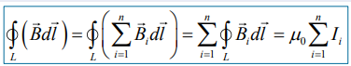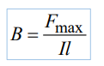

Energia câmpului electric

Condesatorul sferic

Condesatorul cilindric

Condensatorul plan

Capacitatea electrică

Legea lui Hooke

Forța de frecare la alunecare

Legea atracției universale

Legea mișcării centrului de masă

Legea conservării impulsului